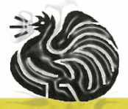
Wauchope Poultry Club INC.
15TH Annual Rare Breeds, Rare Colour & Waterfowl Show

When:
SATURDAY 25TH May 2024
Where:
Harley Cooke Pavilion, Wauchope Showground,
High St Wauchope
N.S.W 2446

Entry Fee $2.00
Limited to 800 Entries Entries to Wauchope Poultry Club Secretary
Scott Balmer
PO BOX 325 WAUCHOPE NSW 2430
Entries Close 18th May at 5pm
Money Orders/Cheques to be made out to Wauchope Poultry Club NO PHONE ENTRIES!

JUDGE’S
Guy Wailes
Clayton Kirkham

PRESIDENT: Daniel Cooke EMAIL: wauchopepoultryclub@gmail.com PH: 0401 260 731 SECRETARY: Heather Lattimore EMAIL: wauchopepoultryclub@gmail.com
PH: (02)65504329

THE RHODE ISLAND CLUB OF N.S.W NORTHERN BRANCH WILL ALSO BE HOLDING A SHOW IN CONJUNCTION WITH US

www.wauchopepoultryclub.com.au

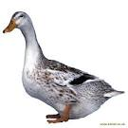
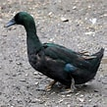
CHAMPION RARE BIRD OF SHOW
$50 & SASH
CHAMPION RARE COLOUR BIRD OF SHOW
$50 & SASH
CHAMPION WATERFOWL
$50 & SASH

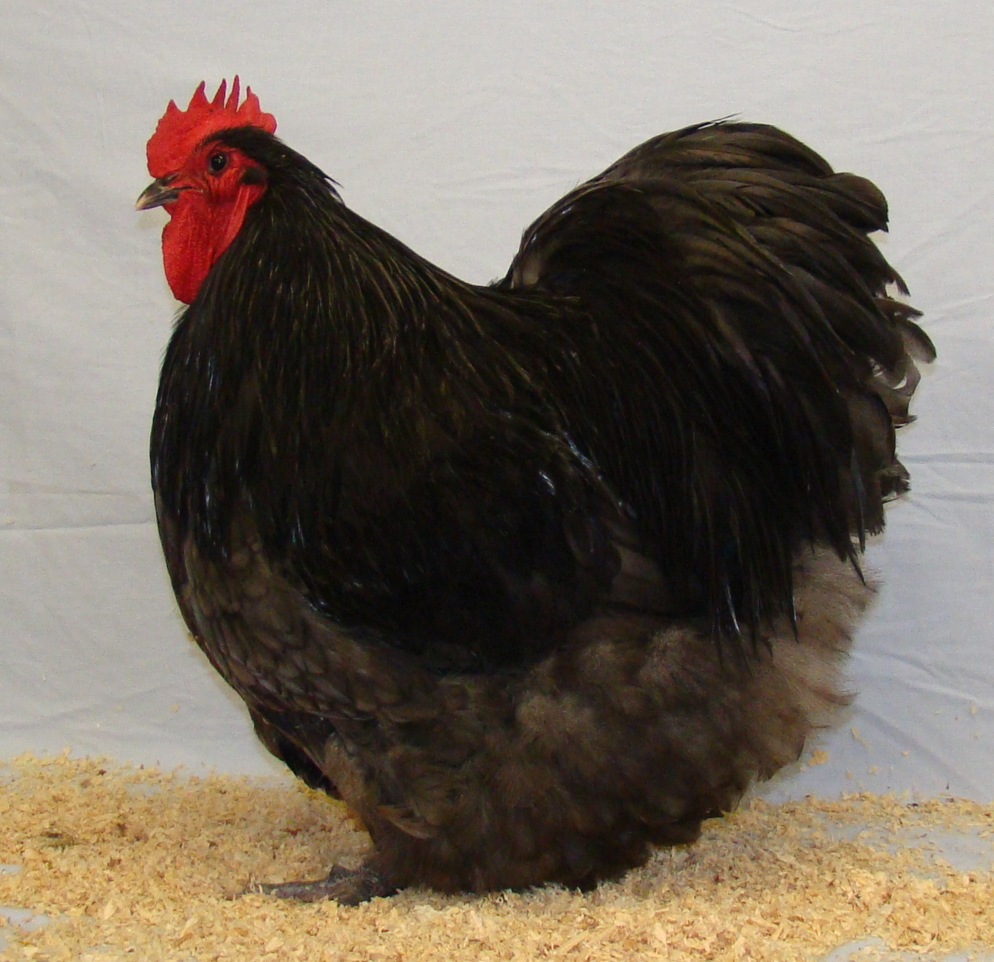

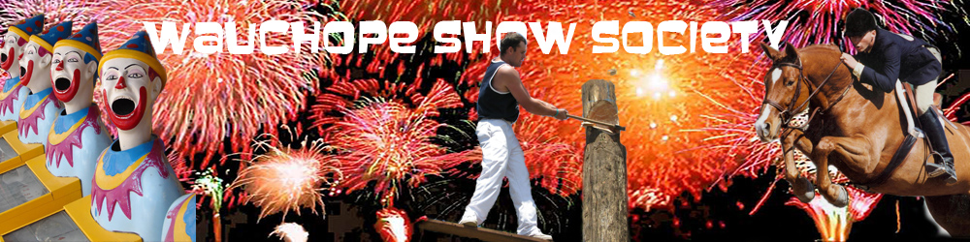

CANTEEN AVAILABLE ON DAY

SASHES & PRIZE MONEY

CHAMPION RARE BREED OVERALL $50 & SASH RESERVE CHAMPION RARE BREED OVERALL $30 & SASH CHAMPION STANDARD RARE BREED $15 & SASH RESERVE CHAMPION STANDARD RARE BREED $10 & SASH CHAMPION BANTAM RARE BREED $15 & SASH RESERVE CHAMPION BANTAM RARE BREED $10 & SASH RARE BREED CHAMPIONS (5 OR MORE TO A CLASS) $5 & SASH
CHAMPION RARE COLOUR OVERALL $50 & SASH RESERVE CHAMPION RARE COLOUR OVERALL $30 & SASH CHAMPION STANDARD RARE COLOUR $15 & SASH RESERVE CHAMPION STANDARD RARE COLOUR $10 & SASH CHAMPION BANTAM RARE COLOUR $15 & SASH RESERVE CHAMPION BANTAM RARE COLOUR $10 & SASH RARE COLOUR CHAMPIONS (5 OR MORE TO A CLASS) $5 & SASH

CHAMPION WATERFOWL
$50 & SASH
RESERVE CHAMPION WATERFOWL
$30 & SASH
CHAMPION BANTAM
$10 & SASH
CHAMPION LIGHT BREED
$10 & SASH
CHAMPION HEAVY BREED
$10 & SASH
WATERFOWL BREED CHAMPIONS
(5 OR MORE ENTRIES IN CLASS)
$5 & SASH

Thank You for Sponsoring our Show
THE WAUCHOPE POULTRY CLUB RARE BREEDS SHOW WILL BE RUN IN THREE SECTIONS,
RARE BREEDS, RARE COLOURS & WATERFOWL
THE WAUCHOPE POULTRY CLUB HAS SELECTED THE BREEDS & COLOURS IN THIS SCHEDULE ACCORDING TO THE CURRENT TRENDS & WHAT WE CONSIDER TO BE RARE WITHIN OUR REGION THE LIST IS SUBJECT TO ANNUAL REVIEW

ENTRY CONDITIONS: 1.All birds must be penned by 8.15 am on day of show or night before show, between 6.00pm & 8.30pm 2. Birds arriving sick will not be penned 3. Birds must not be removed from pens or handled without permission from Chief Steward. 4. All birds will be cared for by the club but the club cannot be held responsible for any loss or damage incurred during the shows duration. 5. The Judges decision is final. 6. Entries received without entry fees will not be accepted and will be returned to sender. 7. Phone entries will not be accepted. 8. No birds will be removed from cages without a steward or Wauchope Club member in attendance. 9. The Wauchope Poultry Club Inc. reserves the right to join two classes in the event of insufficient entries and to make AOC & AOV classes if entries warrant. 10. Any breed that has more than 5 in one colour can have a class of its own. 11. All AOV & AOC Classes please specify what colour the bird is. 12. Juniors must pen & unpen their own birds. (N0 Junior section)

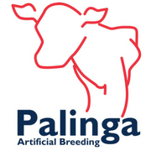

Thank you for Sponsoring our Show
Wauchope Poultry Club Membership
Yearly Membership
Adults $10 Family $25 Juniors $5
Membership includes a monthly newsletter The Chook Run & access to our Poultry Book Library

INELIGIBLE VARIETIES FOR OUR 2024 SHOW
SOFT FEATHER LARGE Ancona – Black Langshan – Black Australorp – Black Leghorn – White, Black, Plymouth Rock- Barred Rhode Island –All Silkie – White, Bearded White Sussex- Light Wyandotte – White, Gold Laced, Silver Laced
SOFT FEATHER BANTAM Ancona – Black Australorp - Black Belgian D’Uccle – Millefleur, Black, Porcelain, Mottled, White ,Normal Quail Belgian D’Anvers- Normal Quail, Lavender, Black Langshan – Black Leghorn- White, Black, Pekin- Black, White Plymouth Rock – Dark Barred. Rhode Island- All Sussex- Light Wyandotte- White, Columbian, Gold Laced, Silver Laced,
HARD FEATHER LARGE Australian Pits- All Australian Game- Black-Red, Duckwing, Blue-Red Indian Game- Dark, Jubilee Old English Game- Black-Red, including Partridge, Brown-Red, Blue-Red, Duckwing all
HARD FEATHER BANTAM Australian Pits- All Australian Game- Black-Red, Indian Game- Dark, Jubilee Modern Game- Black-Red, Pile, Silver Duckwing & Gold Duckwing Old English Game- Black-Red, including Wheaton & Partridge, Brown-Red, Blue-Red, Blue Tailed Wheaton, Duckwing all, Pile

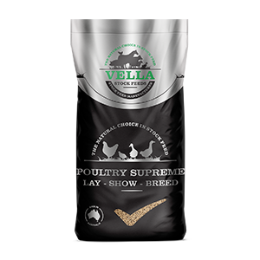
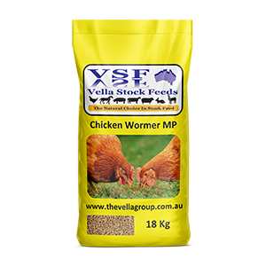
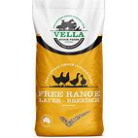

Thank you for Sponsoring our Show

WAUCHOPE POULTRY CLUB RARE BREED SHOW
RARE BREED LARGE
BREED | COCK | HEN | COCKEREL | PULLET
ANDALUSIAN | 1 | 2 | 3 | 4
ARAUCANA LAVENDER | 5 | 6 | 7 | 8
ARAUCANA AORC | 9 | 10 | 11 | 12
BARNEVELDER DOUBLE LACED | 13 | 14 | 15 | 16
BARNEVELDER BLACK | 17 | 18 | 19 | 20
BARNEVELDER AORC | 21 | 22 | 23 | 24
BRAHMA LIGHT | 25 | 26 | 27 | 28
BRAHMA AORC | 29 | 30 | 31 | 32
CAMPINE SILVER | 33 | 34 | 35 | 36
CAMPINE GOLD | 37 | 38 | 39 | 40
COCHIN ARC | 41 | 42 | 43 | 44
CROAD LANGSHAN BLACK | 45 | 46 | 47 | 48
CROAD LANGSHAN AORC | 49 | 50 | 51 | 52
DORKING SILVER GREY | 53 | 54 | 55 | 56
DORKING AORC | 57 | 58 | 59 | 60
FAVEROLLES SALMON | 61 | 62 | 63 | 64
FAVEROLLES BLACK | 65 | 66 | 67 | 68
FAVEROLLES AORC | 69 | 70 | 71 | 72
FRIZZLE ARC | 73 | 74 | 75 | 76
HAMBURGH SPANGLED | 77 | 78 | 79 | 80
HAMBURGH PENCILLED | 81 | 82 | 83 | 84
HAMBURGH AORC | 85 | 86 | 87 | 88
HOUDAN ARC | 89 | 90 | 91 | 92
JUNGLE FOWL | 93 | 94 | 95 | 96
MALAY GAME ARC | 97 | 98 | 99 | 100
MODERN GAME ARC | 101 | 102 | 103 | 104
MINORCA BLACK | 105 | 106 | 107 | 108
MINORCA AORC | 109 | 110 | 111 | 112
ORPINGTON BLACK | 113 | 114 | 115 | 116
ORPINGTON BLUE | 117 | 118 | 119 | 120
ORPINGTON AORC | 121 | 122 | 123 | 124
WAUCHOPE POULTRY CLUB RARE BREED SHOW
RARE BREED LARGE CONTINUED
BREED | COCK | HEN | COCKEREL | PULLET
MARANS ARC | 125 | 126 | 127 | 128
NAKED NECK BLACK | 129 | 130 | 131 | 132
NAKED NECK AORC | 133 | 134 | 135 | 136
NEW HAMPSHIRE RED | 137 | 138 | 139 | 140
PHOENIX | 141 | 142 | 143 | 144
POLISH WHITE CRESTED BLACK | 145 | 146 | 147 | 148
POLISH WHITE CRESTED AORC | 149 | 150 | 151 | 152
POLISH AORC | 153 | 154 | 155 | 156
SPANISH ARC | 157 | 158 | 159 | 160
SICILIAN BUTTERCUP | 161 | 162 | 163 | 164
WELSUMMER PARTRIDGE | 165 | 166 | 167 | 168
WELSUMMER AORC | 169 | 170 | 171 | 172
YOKOHAMA | 173 | 174 | 175 | 176
ANY OTHER ELIGIBLE BREED | 177 | 178 | 179 | 180

PROUDLY SUPPORTED BY.

Thank You for Sponsoring our Show
WAUCHOPE POULTRY CLUB RARE BREED SHOW
RARE BREED BANTAM
BREED | COCK | HEN | COCKEREL | PULLET
ANDALUSIAN | 181 | 182 | 183 | 184
ARAUCANA LAVENDER | 185 | 186 | 187 | 188
ARAUCANA AORC | 189 | 190 | 191 | 192
BARNEVELDER ARC | 193 | 194 | 195 | 196
BRAHMA ARC | 197 | 198 | 199 | 200
CAMPINE SILVER | 201 | 202 | 203 | 204
CAMPINE GOLD | 205 | 206 | 207 | 208
CROAD LANGSHAN ARC | 209 | 210 | 211 | 212
DORKING ARC | 213 | 214 | 215 | 216
FAVEROLLES SALMON | 217 | 218 | 219 | 220
FAVEROLLES BLACK | 221 | 222 | 223 | 224
FAVEROLLES AORC | 225 | 226 | 227 | 228
FRIZZLE ARC | 229 | 230 | 231 | 232
HAMBURGH AC SPANGLED | 233 | 234 | 235 | 236
HAMBURGH AC PENCILLED | 237 | 238 | 239 | 240
HAMBURGH AORC | 241 | 242 | 243 | 244
HOUDAN ARC | 245 | 246 | 247 | 248
JAPANESE BLACK TAILED WHITE | 249 | 250 | 251 | 252
JAPANESE AORC | 253 | 254 | 255 | 256
MALAY GAME ARC | 257 | 258 | 259 | 260
MINORCA BLACK | 261 | 262 | 263 | 264
MINORCA AORC | 265 | 266 | 267 | 268
NAKED NECK BLACK | 269 | 270 | 271 | 272
NAKED NECK AORC | 273 | 274 | 275 | 276
NEW HAMPSHIRE RED | 277 | 278 | 279 | 280
ORPINGTON BLACK | 281 | 282 | 283 | 284
ORPINGTON BLUE | 285 | 286 | 287 | 288
ORPINGTON AORC | 289 | 290 | 291 | 292
PHOENIX ARC | 293 | 294 | 295 | 296
WAUCHOPE POULTRY CLUB RARE BREED SHOW
RARE BREED BANTAM CONTINUED
BREED | COCK | HEN | COCKEREL | PULLET
POLISH WHITE CRESTED BLACK | 297 | 298 | 299 | 300
POLISH WHITE CRESTED AORC | 301 | 302 | 303 | 304
POLISH AORC | 305 | 306 | 307 | 308
ROSECOMB BLACK | 309 | 310 | 311 | 312
ROSECOMB AORC | 313 | 314 | 315 | 316
SEBRIGHT GOLD | 317 | 318 | 319 | 320
SEBRIGHT SILVER | 321 | 322 | 323 | 324
SPANISH ARC | 325 | 326 | 327 | 328
SICILIAN BUTTERCUP | 329 | 330 | 331 | 332
SULTAN | 333 | 334 | 335 | 336
WELSUMMER ARC | 337 | 338 | 339 | 340
YOKOHAMA | 341 | 342 | 343 | 344
ANY OTHER ELIGIBLE BREED | 345 | 346 | 347 | 348

18107 PACIFIC HWY, JONES ISLAND NSW 2430

Thank You for Sponsoring our Show

WAUCHOPE POULTRY CLUB RARE COLOUR SHOW
RARE COLOUR LARGE
BREED | COCK | HEN | COCKEREL | PULLET
ANCONA RED | 349 | 350 | 351 | 352
ANCONA ROSECOMB | 353 | 354 | 355 | 356
AUSTRALIAN GAME AEC | 357 | 358 | 359 | 360
AUSTRALORP BLUE | 361 | 362 | 363 | 364
AUSTRALORP WHITE | 365 | 366 | 367 | 368
INDIAN GAME BLUE LACED | 369 | 370 | 371 | 372
LANGSHAN BLUE | 373 | 374 | 375 | 376
LANGSHAN WHITE | 377 | 378 | 379 | 380
LEGHORN BLUE | 381 | 382 | 383 | 384
LEGHORN BUFF | 385 | 386 | 387 | 388
LEGHORN BROWN | 389 | 390 | 391 | 392
LEGHORN DUCKWING AC | 393 | 394 | 395 | 396
LEGHORN PILE | 397 | 398 | 399 | 400
LEGHORN AOEC | 401 | 402 | 403 | 404
OEG WHEATON | 405 | 406 | 407 | 408
OEG SPANGLED | 409 | 410 | 411 | 412
OEG TASSEL / MUFF | 413 | 414 | 415 | 416
OEG AOEC | 417 | 418 | 419 | 420
PLYMOUTH ROCK AEC | 421 | 422 | 423 | 424
SILKIE BLACK | 425 | 426 | 427 | 428
SILKIE BLUE | 429 | 430 | 431 | 432
SILKIE BUFF | 433 | 434 | 435 | 436
SILKIE PARTRIDGE | 437 | 438 | 439 | 440
SILKIE AOEC | 441 | 442 | 443 | 444
SUSSEX CORINATION | 445 | 446 | 447 | 448
SUSSEX BUFF | 449 | 450 | 451 | 452
SUSSEX SPECKLED | 453 | 454 | 455 | 456
SUSSEX AOEC | 457 | 458 | 459 | 460
WYANDOTTE COLUMBIAN | 461 | 462 | 463 | 464
WYANDOTTE BLACK | 465 | 466 | 467 | 468
WAUCHOPE POULTRY CLUB RARE COLOUR SHOW
RARE COLOUR LARGE CONTINUED
WYANDOTTE BLUE | 469 | 470 | 471 | 472
WYANDOTTE BUFF | 473 | 474 | 475 | 476
WYANDOTTE PENCILLED | 477 | 478 | 479 | 480
WYANDOTTE AOEC | 481 | 482 | 483 | 484

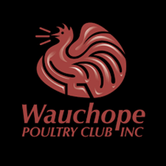

Wauchopepoultryclub@gmail.com

Thank You for Sponsoring our Show

WAUCHOPE POULTRY CLUB RARE COLOUR SHOW
RARE COLOUR BANTAM
BREED | COCK | HEN | COCKEREL | PULLET
ANCONA RED | 485 | 486 | 487 | 488
ANCONA ROSECOMB | 489 | 490 | 491 | 492
AUSTRALIAN GAME AEC | 493 | 494 | 495 | 496
AUSTRALORP BLUE | 497 | 498 | 499 | 500
AUSTRALORP WHITE | 501 | 502 | 503 | 504
BELGIAN D'ANVERS AEC | 505 | 506 | 507 | 508
BELGIAN D'UCCLE AEC | 509 | 510 | 511 | 512
BELGIAN DE WATERMAEL ARC | 513 | 514 | 515 | 516
INDIAN GAME BLUE LACED | 517 | 518 | 519 | 520
LANGSHAN BLUE | 521 | 522 | 523 | 524
LANGSHAN WHITE | 525 | 526 | 527 | 528
LEGHORN BLUE | 529 | 530 | 531 | 532
LEGHORN BUFF | 533 | 534 | 535 | 536
LEGHORN BROWN | 537 | 538 | 539 | 540
LEGHORN DUCKWING AC | 541 | 542 | 543 | 544
LEGHORN PILE | 545 | 546 | 547 | 548
LEGHORN AOEC | 549 | 550 | 551 | 552
MODERN AEC | 553 | 554 | 555 | 556
OEG SPANGLED | 557 | 558 | 559 | 560
OEG TASSEL / MUFF | 561 | 562 | 563 | 564
OEG AOEC | 565 | 566 | 567 | 568
PEKIN BLUE | 569 | 570 | 571 | 572
PEKIN BUFF | 573 | 574 | 575 | 576
PEKIN AOEC | 577 | 578 | 579 | 580
PLYMOUTH ROCK LIGHT BARRED | 581 | 582 | 583 | 584
PLYMOUTH ROCK AEC | 585 | 586 | 587 | 588
SILKIE BLACK | 589 | 590 | 591 | 592
SILKIE BLUE | 593 | 594 | 595 | 596
SILKIE BUFF | 597 | 598 | 599 | 600
SILKIE PARTRIDGE | 601 | 602 | 603 | 604
SILKIE AOEC | 605 | 606 | 607 | 608
WAUCHOPE POULTRY CLUB RARE COLOUR SHOW
RARE COLOUR BANTAM CONTINUED
BREED COCK HEN COCKEREL PULLET
SUSSEX CORINATION | 609 | 610 | 611 | 612
SUSSEX BUFF | 613 | 614 | 615 | 616
SUSSEX SPECKLED | 617 | 618 | 619 | 620
SUSSEX AOEC | 621 | 622 | 623 | 624
WYANDOTTE CUCKOO | 625 | 626 | 627 | 628
WYANDOTTE BLACK | 629 | 630 | 631 | 632
WYANDOTTE BLUE | 633 | 634 | 635 | 636
WYANDOTTE BUFF | 637 | 638 | 639 | 640
WYANDOTTE PENCILLED | 641 | 642 | 643 | 645
WYANDOTTE PARTRIDGE | 646 | 647 | 648 | 649
WYANDOTTE AOEC | 650 | 651 | 652 | 653

SKN Associate, 2/3 High Street, Wauchope, NSW, 2446, Australia
0413 497 910 hello@sknassociate.com.au

Thank you for Sponsoring our Show

HEATHER LATTIMORE & SCOTT BALMER
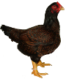
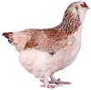

Thank You for Sponsoring our Show

COOKE FAMILY

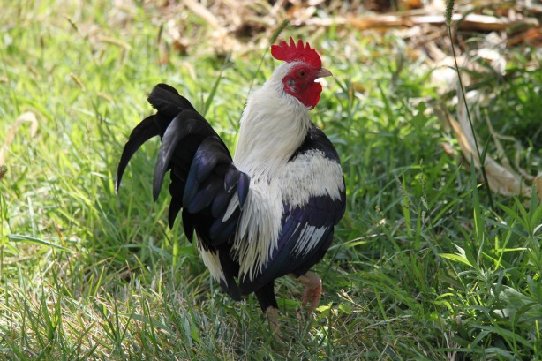

Thank you for Sponsoring our Show

WAUCHOPE POULTRY CLUB WATERFOWL SHOW
WATERFOWL
BREED | DRAKE | DUCK
AUSTRALIAN CALL ARC | 654 | 655
BLACK EAST INDIAN | 656 | 657
MALLARD NORMAL | 658 | 659
MALLARD WHITE | 660 | 661
MALLARD AORC | 662 | 663
BANTAM CRESTED ARC | 664 | 665
BANTAM SAXONY | 666 | 667
BANTAM SILVER APPLEYARD | 668 | 669
BANTAM WELSH HARLEQUIN | 670 | 671
ANY OTHER BREED BANTAM | 672 | 673
ABACOT RANGER | 674 | 675
BALI | 676 | 677
CAMPBELL ARC | 678 | 679
CRESTED ARC | 680 | 681
ELIZABETH | 682 | 683
INDIAN RUNNER WHITE | 684 | 685
INDIAN RUNNER BLACK | 686 | 687
INDIAN RUNNER FAWN & WHITE | 688 | 689
INDIAN RUNNER AORC | 690 | 691
ORPINGTON ARC | 692 | 693
ANY OTHER BREED LIGHT | 694 | 695
AYLESBURY | 696 | 697
BLUE SWEDISH | 698 | 699
CAYUGA | 700 | 701
MUSCOVY WHITE | 702 | 703
MUSCOVY AORC | 704 | 705
PEKIN | 706 | 707
ROUEN | 708 | 709
SAXONY | 710 | 711
SILVER APPLEYARD | 712 | 713
WAUCHOPE POULTRY CLUB WATERFOWL SHOW
WATERFOWL CONTINUED
ANY OTHER BREED HEAVY | 714 | 715
GEESE | GANDER | GOOSE
ANY BREED OF GEESE | 716 | 717
PLEASE NOTE WE ONLY HAVE A SMALL AMOUNT OF PENS BIG ENOUGH TO FIT GEESE

AEC – ANY ELIGIBLE COLOUR AOEC – ANY OTHER ELIGIBLE COLOUR
BREEDS MUST BE FROM THE AUSTRALIAN POULTRY STANDARDS

Imported Breeds
(To Be Judged to the British Standard)

 | Cock | Hen | Cockerel | Pullet
Any Imported Variety | 718 | 719 | 720 | 721
Development Class
This is a colour that is not listed for that breed in the Australian Poultry Standard Second Edition (These classes ineligible for majors)
Rare Breed Large | 722 | 723 | 724 | 725
Rare Breed Bantam | 726 | 727 | 728 | 729
Rare Colour Large | 730 | 731 | 732 | 733
Rare Colour Bantam | 734 | 735 | 736 | 737

WAUCHOPE POULTRY CLUB RARE BREEDS AND WATERFOWL SHOW
Please complete both sides and return to
The Show Secretary SCOTT BALMER Po Box 325 WAUCHOPE N.S.W 2446
Ph. 0428861916
Entries close 18TH May 2023
CLUB COPY EXHIBITORS COPY
N0 | Class | Name & Colour of Breed | Pen | No | Class | Name & Colour of Breed | Pen
1 |  |  |  | 1
2 |  |  |  | 2
3 |  |  |  | 3
4 |  |  |  | 4
5 |  |  |  | 5
6 |  |  |  | 6
7 |  |  |  | 7
8 |  |  |  | 8
9 |  |  |  | 9
10 |  |  |  | 10
11 |  |  |  | 11
12 |  |  |  | 12
13 |  |  |  | 13
14 |  |  |  | 14
15 |  |  |  | 15
16 |  |  |  | 16
17 |  |  |  | 17
18 |  |  |  | 18
19 |  |  |  | 19
20 |  |  |  | 20
21 |  |  |  | 21
22 |  |  |  | 22
23 |  |  |  | 23
24 |  |  |  | 24
25 |  |  |  | 25
26 |  |  |  | 26
27 |  |  |  | 27
28 |  |  |  | 28
29 |  |  |  | 29
30 |  |  |  | 30
31 |  |  |  | 31
32 |  |  |  | 32
33 |  |  |  | 33
NO. OF ENTRIES ………………@ $2.00 |  |  | $ | NO. OF ENTRIES…………….@ $2.00 |  |  | $
DONATION (OPTIONAL) |  |  | $ | DONATION (OPTIONAL) |  |  | $
TOTAL |  |  | $ | TOTAL |  |  | $
NAME: |  |  |  | NAME:
ADDRESS: |  |  |  | ADDRESS:
PHONE: |  |  |  | PHONE:
EMAIL: |  |  |  | EMAIL:

