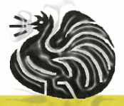 **Wauchope Poultry Club INC.**

**Wauchope Poultry Club**

**INVITES YOU TO OUR**

**2025 Poultry Auction**

**Sunday 4TH May 2025 Viewing From 9:00 am Auction Starts 10:00 am**

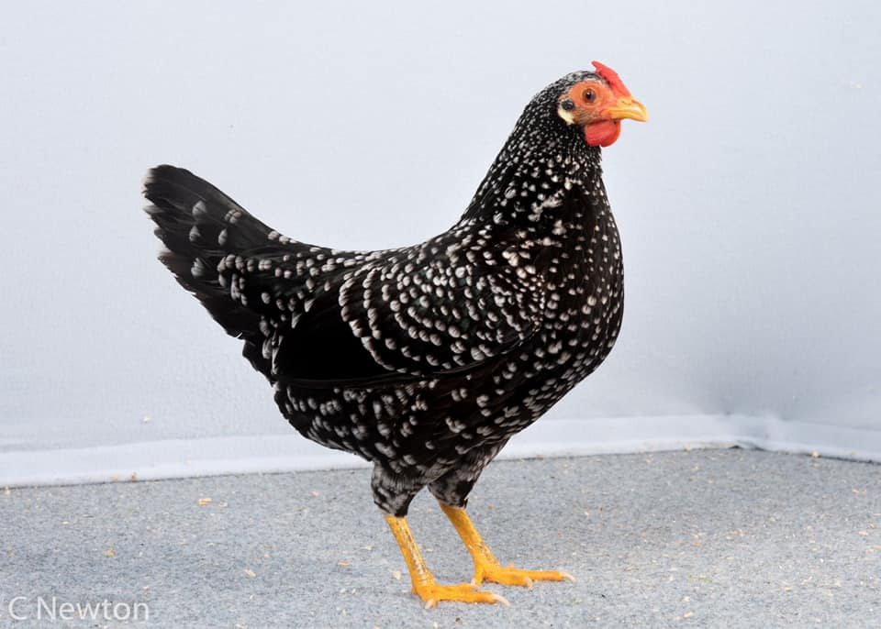

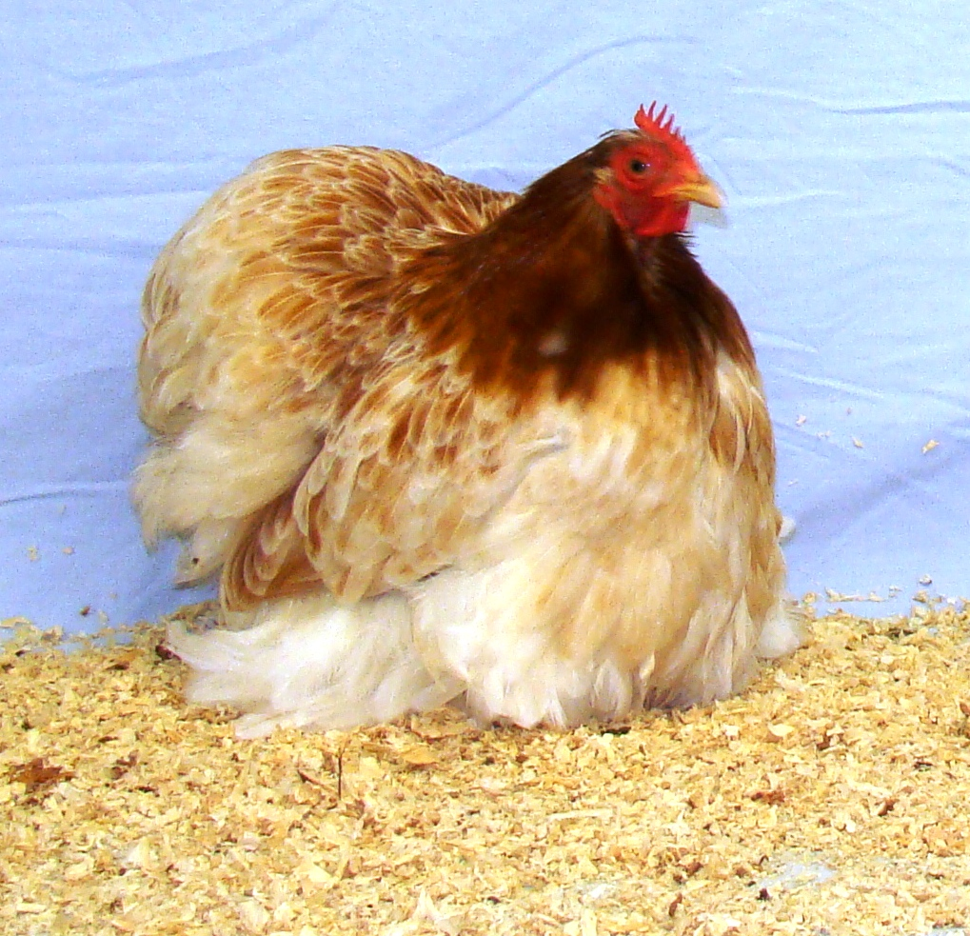

**HARLEY COOKE PAVILION, WAUCHOPE SHOWGROUND**

**HIGH STREET WAUCHOPE NSW 2446**

**Canteen Facilities Available**

**www.wauchopepoultryclub.com.au**

* **Auction Rules**
* You are invited to inspect all lots prior to the auction. Viewing begins at 9:00am (Lots can be handled with the company of a steward)
* Lots passed in may be sold by private treaty. Any such sales after the auction must be paid to the Wauchope Poultry Club Inc. and a docket must be obtained prior to the release of lots.
* The last bidder on a lot that is passed in has first offer at the reserve price.
* Lots will be offered in numerical order as listed in the catalogue
* All transactions must be STRICTLY CASH, unless prior arrangement with the Wauchope Poultry Club Inc to accept cheques.
* LOTS WILL ONLY BE RELEASED AFTER THE AUCTION. Birds will ONLY be unpenned by authorised stewards only.
* The system of bidders’ cards and numbers will be used. Please ensure you have your number prior to the commencement of the sale.
* Wauchope Poultry Club Inc accepts no responsibility for incorrect descriptions of any lots or any claims made by the vendor.
* This auction is conducted under the Constitution of By-Laws of the Wauchope Poultry Club Inc. and the usual terms of a public auction.
* All care is taken to ensure the safety of all birds and equipment, but in the event of any loss or injury, the Wauchope Poultry Club Inc. accepts no responsibility.
* Lots remain the liability of the vendor until the fall of the hammer, upon which the purchaser assumes responsibility.
* The Wauchope Poultry Club Inc. reserves the right to alter, delete or make additions to these rules as circumstances dictate.
* Minimum bid will be $5.00 per bird. $10 per pair. $15 per trio.

NOTE

* For the purpose of the catalogue, Breeding Pair and Trio’s means.ie. one male and one or two females. Otherwise, if just pair or trio means 2 or 3 Female
* Plt = Pullet
* Ckl = Cockerel
* Btm = Bantam
* RIR = Rhode Island Red (Breed)
* OEG = Old English Game (Breed)
* PB = Pullet Breeders (only Breeds Exhibition Females)
* CB = Cockerel Breeders (only Breeds Exhibition Males)

**What you need to know about our Auction-**

THIS CATALOGUE IS A GUIDE ONLY!

Lots may be changed or altered by the vendor as the catalogue is prepared and printed in advance.

Check the cage carefully as what is in the cage is what you are bidding on NOT what’s in the catalogue!

If you have any questions, please ask one of our members wearing the Wauchope Poultry Club Shirt (Red Shirts). They will be happy to help you.

If you see a sick bird, please bring it to our attention.

The Auctioneer decision is final.

Please bring your own boxes.

Lots will not be released if you have no suitable way to get them home.

No bags of any sort are to be used to transport poultry.

Please have an enjoyable day but treat our volunteers with respect.

Any abuse will not be tolerated.

| Lot | Vendor Name | Breed | Description | Price | Buyer |
| --- | --- | --- | --- | --- | --- |
| 1 | **ELLISE CAYIR** | **LEGBAR X MARAN** | **PULLET** |  |  |
| 2 | **ELLISE CAYIR** | **LEGBAR** | **HEN** |  |  |
| 3 | **TENEALE MITCHELL** | **BRAHMA** | **PAIR RED PULLETS** |  |  |
| 4 | **TENEALE MITCHELL** | **BRAHMA** | **PAIR RED PULLETS** |  |  |
| 5 | **B. CROSSFIELD** | **SILKIE** | **HEN 2ND LAY** |  |  |
| 6 | **LISA PARRY** | **SUSSEX** | **LIGHT HEN** |  |  |
| 7 | **B. CROSSFIELD** | **SILKIE** | **HEN 2ND LAY** |  |  |
| 8 | **LISA PARRY** | **SUSSEX** | **LIGHT PULLET** |  |  |
| 9 | **LISA PARRY** | **SUSSEX** | **LIGHT HEN** |  |  |
| 10 | **IAN MC GOLDRICK** | **AUSTRALAIN GAME** | **PAIR LARGE** |  |  |
| 11 | **IAN MC GOLDRICK** | **AUSTRALAIN GAME** | **PAIR LARGE** |  |  |
| 12 | **EMILY AND LACHLAN DAVIS** | **POLISH** | **2 PULLETS (1 WHITE AND 1 GOLDLACED MIXED COLOUR)** |  |  |
| 13 | **JOHN MINETT** | **AUSTRALORP** | **BLUE PULLET** |  |  |
| 14 | **CATHY CROSS** | **LEGBAR** | **CREAM HEN** |  |  |
| 15 | **CATHY CROSS** | **LEGBAR** | **ROOSTER** |  |  |
| 16 | **CATHY CROSS** | **LEGBAR** | **ROOSTER** |  |  |
| 17 | **BRYAN ALLEY** | **AUSTRALORP** | **LAVENDER LARGE CKL** |  |  |
| 18 | **BRYAN ALLEY** | **AUSTRALORP** | **BLACK LARGE CKL** |  |  |
| 19 | **SEB GOLDMAN** | **DUTCH-GOLD** | **TRIO 14 MONTH CKL, 14 MONTH HEN, 1O MONTH PULLET** |  |  |
| 20 | **CATHY CROSS** | **WYANDOTTE** | **BLUE LACED FEMALE** |  |  |
| 21 | **CATHY CROSS** | **WYANDOTTE** | **BLUE LACED FEMALE** |  |  |
| 22 | **B. CROSSFIELD** | **SILKIE X** | **2 PULLETS** |  |  |
| 23 | **B. CROSSFIELD** |  | **2 PULLETS (1 BLACK AND 1 WHITE)** |  |  |
| 24 | **TENEALE MITCHELL** | **PEKIN** | **TRIO MILLIFLUER** |  |  |
| 25 | **TENEALE MITCHELL** | **PEKIN** | **TRIO MILLIFLUER** |  |  |
| 26 | **JOHN MINETT** | **AUSTRALORP** | **BLUE HEN** |  |  |
| 27 | **JOHN MINETT** | **AUSTRALORP** | **BLACK HEN** |  |  |
| 28 | **RUBY WEISMANTEL** | **SUSSEX** | **SPECKLED CKL** |  |  |
| 29 | **RUBY WEISMANTEL** | **SUSSEX** | **SPECKLED CKL** |  |  |
| 30 | **LAYLA & GRACE WHATMAN** | **AUSTRALORP** | **6 MONTHS OLD** (BRED FROM DANIEL’S CHICKEN CARAVAN’S) |  |  |
| 31 | **LISA PARRY** | **SUSSEX** | **LIGHT PLT** |  |  |
| 32 | **LISA PARRY** | **SUSSEX** | **2 LIGHT PLTS** |  |  |
| 33 | **JOHN MINETT** | **WYANDOTTE** | **BREEDING TRIO GOLD LACED** |  |  |
| 34 | **LAYLA & GRACE WHATMAN** | **AUSTRALORP** | **6 MONTHS OLD** (BRED FROM DANIEL’S CHICKEN CARAVAN’S) |  |  |
| 35 | **LAYLA & GRACE WHATMAN** | **AUSTRALORP** | **6 MONTHS OLD** (BRED FROM DANIEL’S CHICKEN CARAVAN’S) |  |  |
| 36 | **JOHN MINETT** | **AUSTRALORP** | **BLUE HEN** |  |  |
| 37 | **JOHN MINETT** | **AUSTRALORP** | **LAVENDER** |  |  |
| 38 | **TENEALE MITCHELL** | **PEKIN** | **TRIO MILLIFLUER** |  |  |
| 39 | **TENEALE MITCHELL** | **PEKIN** | **TRIO** |  |  |
| 40 | **ANGELA FROST** | **SUSSEX** | **2 SPECKLED PLTS** |  |  |
| 41 | **LISA PARRY** | **PEKIN** | **2 CHOCLOATE PLTS** |  |  |
| 42 | **JANINE ROBERTS** | **AUSTRALORP** | **SPLASH HEN & BLACK CKL** |  |  |
| 43 | **JANINE ROBERTS** | **BARNEVELDER** | **1 HEN & (BARNEVELDER X AUSTRALORP ROOSTER- 5 MONTHS OLD)** |  |  |
| 44 | **JAMES TAIT** | **AUSTRALORP** | **2 PULLETS** |  |  |
| 45 | **JAMES TAIT** | **AUSTRALORP** | **3 PULLETS** |  |  |
| 46 | **JOHN MINETT** | **BARNEVELDER** | **SILVER DOUBLE LACED HEN** |  |  |
| 47 | **JOHN MINETT** | **BARNEVELDER** | **SILVER DOUBLE LACED HEN** |  |  |
| 48 | **RUBY WEISMANTEL** | **SUSSEX** | **LIGHT CKL** |  |  |
| 49 | **JANINE ROBERTS** | **AUSTRALORP** | **2 HENS** |  |  |
| 50 | **JANINE ROBERTS** | **AUSTRALORP X BARNEVELDER** | **CKL (5 MONTHS)** |  |  |
| 51 | **JAMES TAIT** | **SILKIE** | **2 PULLETS** |  |  |
| 52 |  |  |  |  |  |
| 53 | **MICHELLE LATA** | **AUSTRAILA GAME** | **BLACK & WHITE ROOSTER** |  |  |
| 54 | **JOHN MINETT** | **AUSTRALORP** | **BLUE PULLET** |  |  |
| 55 | **JOHN MINETT** | **AUSTRALORP** | **LAVENDER HEN** |  |  |
| 56 | **TENEALE MITCHELL** | **PEKIN** | **TRIO** |  |  |
| 57 | **TENEALE MITCHELL** | **PEKIN** | **2 GOLD LACED PLTS** |  |  |
| 58 | **BEN** | **HAMBURGH** | **BLACK** |  |  |
| 59 | **BEN** | **HAMBURGH** | **WHITE** |  |  |
| 60 | **MICHELLE LATA** | **AUSTRALIAN GAME** | **WHITE ROOSTER** |  |  |
| 61 | **MICHELLE LATA** | **AUSTRALIAN GAME** | **COLOURED ROOSTER & WHITE HEN** |  |  |
| 62 | **ELLISE CAYIR** | **MARAN** | **2 BIRCHEN PULLETS** |  |  |
| 63 | **ELLISE CAYIR** | **MARAN** | **2 BIRCHEN PULLETS** |  |  |
| 64 | **LISA PARRY** | **PEKIN** | **2 MILLIFLURE PLTS** |  |  |
| 65 | **JIANNA SMITH** | **ARACAUNA** | **SPLASH CKL** |  |  |
| 66 | **MICHELLE LATA** | **AUSTRALIAN GAME** | **PAIR WHITE** |  |  |
| 67 | **BEN** | **HAMBURGH** | **WHITE WITH GOLD SPECK** |  |  |
| 68 | **BEN** | **HAMBURGH** | **GOLDEN LACED** |  |  |
| 69 | **ELLISE CAYIR** | **MARAN** | **HEN** |  |  |
| 70 | **ELLISE CAYIR** | **MARAN** | **BLACK PLT** |  |  |
| 71 | **LISA PARRY** | **SUSSEX** | **LIGHT HEN** |  |  |
| 72 | **JOHN MINETT** | **AUSTRALORP** | **BLUE PULLET** |  |  |
| 73 | **JOHN MINETT** | **AUSTRALORP** | **SPLASH HEN** |  |  |
| 74 | **BEN** | **AUSTRALORP** | **ROOSTER** |  |  |
| 75 | **BRYAN ALLEY** | **WYANDOTTE** | **SILVER LACED CKL (20 MONTHS)** |  |  |
| 76 | **BRYAN ALLEY** | **WYANDOTTE** | **BUFF CKL (TOP QUALITY)** |  |  |
| 77 | **ELLISE CAYIR** | **BRAHMA** | **GOLD PARTRIDGE PLT & CKL IMPORT LINES** |  |  |
| 78 | **LISA PARRY** | **SUSSEX** | **LIGHT PLT** |  |  |
| 79 | **LISA PARRY** | **SUSSEX** | **LIGHT HEN** |  |  |
| 80 | **EMILY & LACHLAN DAVIS** | **POLISH** | **2 WHITE PLTS** |  |  |
| 81/82 | **JIANNA SMITH** | **SUSSEX** | **PAIR LAVENDER CKL & PLT** |  |  |
| 83 | **BRYAN ALLEY** | **WYANDOTTE** | **PARTRIDGE HEN (2ND LAY)** |  |  |
| 84 | **ELLISE CAYIR** | **BRAHMA** | **2 HENS** |  |  |
| 85 | **ELLISE CAYIR** | **BRAHMA** | **GOLD PARTRIDGE POL X2 IMPORT LINES** |  |  |
| 86 | **ELLISE CAYIR** | **BRAHMA** | **GOLD PARTRIDGE CKL IMPORT LINES** |  |  |
| 87 | **LISA PARRY** | **PEKIN** | **PORCELAIN PLT** |  |  |
| 88 | **BRYAN ALLEY** | **ARAUCANA** | **PULLET** |  |  |
| 89 | **BRYAN ALLEY** | **ARAUCANA** | **2 PULLETS** |  |  |
| 90 | **TENEALE MITCHELL** | **SILKIE** | **2 YOUNG WHITE** |  |  |
| 91 | **ELLISE CAYIR** | **MARAN** | **CUCKOO CKL** |  |  |
| 92 | **JOHN MINETT** | **AUSTRALORP** | **BLUE PULLET** |  |  |
| 93 | **JOHN MINETT** | **AUSTRALORP** | **SPLASH HEN** |  |  |
| 94/95 | **G.A JORDAN** | **WATERFOWL** | **PAIR ROUEN** |  |  |
| 96 | **LISA PARRY** | **GREY** | **DORKING PLT** |  |  |
| 97 | **TENEALE MITCHELL** | **WATERFOWL** | **ORPINGTON BUFF DRAKE** |  |  |
| 98 | **TENEALE MITCHELL** | **WATERFOWL** | **ORPINGTON BUFF DRAKE** |  |  |
| 99 | **TENEALE MITCHELL** | **WATERFOWL** | **ORPINGTON BUFF DRAKE** |  |  |
| 100/101/102 | **G.A JORDAN** | **WATERFOWL** | **TRIO ROUEN** |  |  |
| 103 | **JIANNA SMITH** | **WATERFOWL** | **PAIR CAYUGA** |  |  |
| 104 | **LISA PARRY** | **ORPINGTON** | **BUFF CKL** |  |  |
| 105 | **LISA PARRY** | **SUSSEX** | **LIGHT CKL** |  |  |
| 106 | **EMILY & LACHLAN DAVIS** | **MIXED** | **3 POLISH X PLTS** |  |  |
| 107 | **EMILY & LACHLAN DAVIS** | **MIXED** | **3 LAYER PLTS** |  |  |
| 108 | **LISA PARRY** | **SUSSEX** | **LIGHT CKL** |  |  |
| 109 | **ELLISE CAYIR** | **MIXED** | **POL PLT** |  |  |
| 110 | **LISA PARRY** | **SUSSEX** | **LIGHT PLT** |  |  |
| 111 | **LISA PARRY** | **SUSSEX** | **LIGHT HEN** |  |  |
| 112 | **EMILY & LACHLAN DAVIS** | **MIXED** | **2 LAYER PLTS** |  |  |
| 113 | **ELLISE CAYIR** | **ARAUCANA** | **WHITE PLT AND CKL** |  |  |
| 114 | **ELLISE CAYIR** | **ARAUCANA** | **ROOSTER 1ST SEASON** |  |  |
| 115 | **LISA PARRY** | **SUSSEX** | **2 LIGHT HENS** |  |  |
| 116 | **BRYAN ALLEY** | **WYANDOTTE** | **BREEDING PAIR PARTRIDGE BTM** |  |  |
| 117 | **B. CROSSFIELD** | **FRIZZLE-SILKIE** | **HEN 2ND LAY** |  |  |
| 118 | **LISA PARRY** | **SUSSEX** | **2 LIGHT HENS** |  |  |
| 119 | **ELLISE CAYIR** | **ISA BROWN X** | **HEN** |  |  |
| 120/121 | **LISA PARRY** | **SUSSEX** | **TRIO LIGHT** |  |  |
| 122 | **LISA PARRY** | **PEKIN** | **TRIO MILLIFLURE (CKL & 2 PLTS)** |  |  |
| 123 | **ELLISE CAYIR** | **WATERFOWL** | **2 INDIAN RUNNER (1 POL & 1 SECOND YEAR)** |  |  |
| 124 | **LISA PARRY** | **PEKIN** | **TRIO MILLIFLUER (CKL & 2 PLTS)** |  |  |
| 125 | **ELLISE CAYIR** | **WATERFOWL** | **2 INDIAN RUNNER CHOCOLATE POL** |  |  |
| 126 | **ELLISE CAYIR** | **WATERFOWL** | **2 SILVER POL** |  |  |
| 127 | **B. CROSSFIELD** | **SILKIE** | **PLT** |  |  |
| 128 | **GET A GEM POULTRY** | **GUINEA FOWL** | **PAIR (1 CHOCOLATE AND 1 IVORY)** |  |  |
| 129 | **GET A GEM POULTRY** | **GUINEA FOWL** | **PAIR (1 CHOCOLATE AND 1 IVORY)** |  |  |
| 130 | **GET A GEM POULTRY** | **GUINEA FOWL** | **PAIR (1 PEARL PIED AND 1 LAVENDER)** |  |  |
| 131 | **ROB AND WENDY GRIBBLE** | **RIR** | **BREEDING PAIR** |  |  |
| 132 | **ROB AND WENDY GRIBBLE** | **WYANDOTTE** | **BREEDING PAIR** |  |  |
| 133/134 | **JIANNA SMITH** | **ORPINGTON** | **WHITE CKL & PLT** |  |  |
| 135 | **ROB AND WENDY GRIBBLE** | **RIR** | **BREEDING PAIR** |  |  |
| 136 | **TENEALE MITCHELL** | **PEKIN** | **PAIR WHITE** |  |  |
| 137/138 | **JIANNA SMITH** | **ORPINGTON** | **PAIR BUFF CKL & PLT** |  |  |
| 139 | **KEVIN ROSTEN** | **OEG** | **BREEDING TRIO GINGER RED** |  |  |
| 140 | **STAN MILLS** | **BELGIAN** | **BREEDING TRIO SILVER MILLIFLUER** |  |  |
| 141 | **STAN MILLS** | **BELGIAN** | **BREEDING TRIO (CKL & (2 PLTS- 4/5 MONTHS)** |  |  |
| 142 | **KEVIN ROSTEN** | **OEG** | **BREEDING TRIO CREEL** |  |  |
| 143 | **KEVIN ROSTEN** | **OEG** | **BREEDING TRIO GINGER PILE** |  |  |
| 144 | **KEVIN ROSTEN** | **OEG** | **BREEDING PAIR BLACK RED WHEATEN** |  |  |
| 145 | **KEVIN ROSTEN** | **OEG** | **GOLD DUCKWING CKL** |  |  |
| 146 | **G.A JORDON** | **TURKEY** | **TOM** |  |  |
| 147 | **G.A JORDAN** | **TURKEY** | **TOM** |  |  |
| 148 | **JOSH GUTHRIE** | **SILKIE** | **PAIR WHITE** |  |  |
| 149 | **JOSH GUTHRIE** | **SILKIE** | **APRICOT ROOSTER** |  |  |
| 150 | **STAN MILLS** | **BELGIAN** | **BREEDING TRIO CKL & (2 HENS- 4/5 MONTHS)** |  |  |
| 151 | **KEVIN ROSTEN** | **OEG** | **2 WHEATEN PULLETS** |  |  |
| 152 | **KEVIN ROSTEN** | **OEG** | **GINGER PILE CKL** |  |  |
| 153 | **GEOFF GRADY** | **AUSTRALIAN GAME** | **PAIR LGE BLACK RED** |  |  |
| 154 | **LISA PARRY** | **PEKIN** | **PORCELAIN PLT** |  |  |
| 155 | **ASHEIGH NEWMAN** | **AUSTRALORP** | **BLACK POL PLT** |  |  |
| 156 | **ASHEIGH NEWMAN** | **AUSTRALORP** | **BLACK POL PLT** |  |  |
| 157 | **IAN SCHOTTE** | **INDIAN GAME** | **TRIO DARK BTM** |  |  |
| 158 | **IAN SCHOTTE** | **WYANDOTTE** | **PAIR SILVER PENCILLED BTM** |  |  |
| 159 | **ADAM** | **FRIZZLED NAKED NECK** | **PAIR BTM** |  |  |
| 160 | **ADAM** | **SILKIE** | **ROOSTER** |  |  |
| 161 | **ASHEIGH NEWMAN** | **AUSTRALORP** | **DARK BLUE POL PLT** |  |  |
| 162 | **ASHEIGH NEWMAN** | **WYANDOTTE X** | **GOLD LACED POL PLT** |  |  |
| 163 | **IAN SCHOTTE** | **SILKIE** | **HEN** |  |  |
| 164 | **IAN SCHOTTE** | **INDIAN GAME** | **PAIR JUBILEE BTM** |  |  |
| 165 | **ADAM** |  |  |  |  |
| 166 | **ASHEIGH NEWMAN** | **WYANDOTTE X** | **GOLD LACED (MINIMAL LACING) POL PLT** |  |  |
| 167 | **ASHEIGH NEWMAN** | **WYANDOTTE X** | **RED POL PLT** |  |  |
| 168/169 | **IAN SCHOTTE** | **PLYMOUTH ROCK** | **TRIO BTM** |  |  |
| 170 | **ASHEIGH NEWMAN** | **WYANDOTTE X** | **BLUE RED POL PLT** |  |  |
| 171 | **IAN SCHOTTE** | **MALAY GAME** | **3 HENS** |  |  |
| 172 | **IAN SCHOTTE** | **PEKIN** | **TRIO** |  |  |
| 173/174 | **IAN SCHOTTE** | **WYANDOTTE** | **TRIO BLACK** |  |  |
| 175/176 | **IAN SCHOTTE** | **WYANDOTTE** | **TRIO BUFF LACED** |  |  |
| 177 | **IAN SCHOTTE** | **PITT GAME** | **2 BLACK HEN BTM** |  |  |
| 178 | **IAN SCHOTTE** | **PLYMOUTH ROCK** | **TRIO BTM** |  |  |
| 179 | **IAN SCHOTTE** | **FRIZZLE POLISH** | **TRIO** |  |  |
| 180 | **IAN SCHOTTE** | **POLISH** | **PAIR** |  |  |
| 181 | **IAN SCHOTTE** | **POLISH** | **PAIR** |  |  |
| 182 | **IAN SCHOTTE** | **AUSTRALIAN GAME** | **2 LGE HENS** |  |  |
| 183 | **IAN SCHOTTE** | **BRAHMA** | **2 BLACK HENS** |  |  |
| 184 | **IAN SCHOTTE** | **BRAHMA** | **PAIR BLUE** |  |  |
| 185 | **IAN SCHOTTE** | **GUINEA FOWL** | **3 MIXED COLOURS** |  |  |
| 186 | **IAN SCHOTTE** | **GUINEA FOWL** | **3 LAVENDER** |  |  |
| 187 | **IAN SCHOTTE** | **GUINEA FOWL** | **3 PEARL** |  |  |
| 188/189 | **IAN SCHOTTE** | **MUTANT PHEASANT** | **PAIR** |  |  |
| 190/191 | **IAN SCHOTTE** | **GOLDEN PHEASANT** | **PAIR** |  |  |
| 192 | **LISA PARRY** | **PEKIN** | **PAIR WHITE PLT & LEMON CUCKOO ROOSTER** |  |  |
| 193 | **LISA PARRY** | **PEKIN** | **PAIR CUCKOO PULLETS** |  |  |
| 194 | **TANYA DICKINSON** | **PLYMOUTH ROCK** | **PAIR BTM PLTS (TOP QUALITY)** |  |  |
| 195 | **TANYA DICKINSON** | **ISA BROWN** | **PAIR** |  |  |
| 196 | **TANYA DICKINSON** | **ISA BROWN** | **PAIR** |  |  |
| 197 | **TANYA DICKINSON** | **ISA BROWN** | **PAIR** |  |  |
| 198 | **ELKE ZIRKLER-WILLIAMS** | **ARAUCANA** | **ROOSTER** |  |  |
| 199 | **ALYCIA HUDSON** | **FRIZZLED** | **ROOSTETR** |  |  |
|  |  |  |  |  |  |
| BTM 1 | **IAN MC GOLDRICK** | **AUSTRALIAN GAME** | **PILE BANTAM MALE** |  |  |
| BTM 2 | **IAN MC GOLDRICK** | **AUSTRALIAN GAME** | **PILE BANTAM MALE** |  |  |
| BTM 3 | **WENDY AND ROB GRIBBLE** | **BELGIAN** | **PAIR DE WATERMAEL PONIT OF LAY** |  |  |
| BTM 4 | **WENDY AND ROB GRIBBLE** | **BELGIAN** | **PAIR DE WATERMAEL PONIT OF LAY** |  |  |
| BTM 5 | **KEVIN ROSTEN** | **OEG** | **BREEDING TRIO BLACK RED WHEATEN** |  |  |
| BTM 6 | **KEVIN ROSTEN** | **OEG** | **BREEDING TRIO BLACK RED PARTRIDGE** |  |  |
| BTM 7 | **CATHY CROSS** | **BELGIAN** | **BREEDING TRIO PORCELAIN D’UCCLE** |  |  |
| BTM 8 | **CATHY CROSS** | **BELGIAN** | **BREEDING TRIO SILVER D’UCCLE** |  |  |
| BTM 9 | **CATHY CROSS** | **LEGBAR** | **CREAM FEMALE CHICK** |  |  |
| BTM 10 | **TENEALE MITCHELL** | **PEKIN** | **WHITE CKL** |  |  |
| BTM 11 | **WENDY AND ROB GRIBBLE** | **SEBRIGHT** | **SILVER CKL** |  |  |
| BTM 12 | **MICHELL LATA** | **AUSTRALIAN GAME** | **PAIR** |  |  |
| BTM 13 | **TENEALE MITCHELL** |  | **MILLIFLUER ROOSTER** |  |  |
| BTM 14 | **CATHY CROSS** | **WYANDOTTE** | **2 LACED CHICKS** |  |  |
| BTM 15 | **CATHY CROSS** | **FAVEROLLES** | **SALMON ROOSTER (YOUNG)** |  |  |
| BTM 16 | **KEVIN ROSTEN** | **OEG** | **BREEDING TRIO SILVER DUCKWING** |  |  |
| BTM 17 | **KEVIN ROSTEN** | **OEG** | **BREEDING TRIO GOLD DUCKWING** |  |  |
| BTM 18 | **CATHY CROSS** | **BELGIAN** | **MILLIFLUER HEN** |  |  |
| BTM 19 | **EMILY AND LACHLAN DAVIS** | **BELGIAN** | **BREEDING TRIO BLACK MOTTED** |  |  |
| BTM 20 | **JIANNA SMITH** | **ORPINGTON** | **BTM CKL** |  |  |
| BTM 21 | **TENEALE MITCHELL** | **PEKIN** | **5 DAY OLD CHICKS** |  |  |
| BTM 22 | **TENEALE MITCHELL** | **PEKIN** | **5 DAY OLD CHICKS** |  |  |
| BTM 23 | **TENEALE MITCHELL** | **PEKIN** | **MOTTED CKL** |  |  |
| BTM 24 | **KEVIN ROSTEN** | **OEG** | **BREEDING TRIO GINGER DUCKWING** |  |  |
| BTM 25 | **KEVIN ROSTEN** | **OEG** | **BREEDING TRIO PILE** |  |  |
| BTM 26 | **TENEALE MITCHELL** | **PEKIN** | **4 YOUNG UNSEXED** |  |  |
| BTM 27 | **TENEALE MITCHELL** | **PEKIN** | **4 YOUNG UNSEXED** |  |  |
| BTM 28 | **TENEALE MITCHELL** | **SILKIE** | **5 UNSEXED** |  |  |
| BTM 29 | **STAN MILLS** | **BELGIAN** | **SILVER PORCELAIN CKL (5 MONTHS OLD)** |  |  |
| BTM 30 | **STAN MILLS** | **BELGIAN** | **PORCELAIN HEN (3 ½ YEARS OLD)** |  |  |
| BTM 31 | **JANINE ROBERTS** | **PEKIN X** | **2 HENS** |  |  |
| BTM 32 | **JOSH GUTHRIE** | **BELGIAN** | **PAIR WHITE D’UCCLE** |  |  |
| BTM 33 | **JOSH GUTHRIE** | **BELGIAN** | **TRIO MILLIFLUER D’UCCLE** |  |  |
| BTM 34 | **JANINE ROBERTS** | **PEKIN X** | **2 HENS** |  |  |
| BTM 35 | **STAN MILLS** | **BELGIAN** | **3 HENS (18 MONTHS OLD)** |  |  |
| BTM 36 | **STAN MILLS** | **BELGIAN** | **2 MILLIFLUER PLTS (5 MONTHS)** |  |  |
| BTM 37 | **JANINE ROBERTS** | **PEKIN X** | **HEN** |  |  |
| BTM 38 | **LISA PARRY** | **PEKIN** | **CHOCOLATE CKL** |  |  |
| BTM 39 | **LISA PARRY** | **PEKIN** | **WHITE CKL** |  |  |
| BTM 40 | **JOSH GUTHRIE** | **BELGIAN** | **PAIR MILLIFLUER D’UCCLE** |  |  |
| BTM 41 | **JOSH GUTHRIE** | **BELGIAN** | **PAIR MILLIFLUER D’UCCLE** |  |  |
| BTM 42 | **CATHY CROSS** | **WYANDOTTE** | **2 LACED ROOSTER CHICKS** |  |  |
| BTM 43 | **CATHY CROSS** | **MIXED** | **1 FRIZZLE PLT & 1 PLT CHICK** |  |  |
| BTM 44 | **LISA PARRY** | **PEKIN** | **BLACK CKL** |  |  |
| BTM 45 | **CATHY CROSS** | **MIXED** | **5 UNSEXED CHICKS** |  |  |
| BTM 46 | **CATHY CROSS** | **MIXED** | **3 UNSEXED CHICKS** |  |  |
| BTM 47 | **LISA PARRY** | **PEKIN** | **CHOCOLATE ROOSTER** |  |  |
| BTM 48 | **LISA PARRY** | **PEKIN** | **4 CHICKS** |  |  |
| BTM 49 | **EMILY & LACHLAN DAVS** | **BELGIAN** | **D’ANVER QUAIL PAIR** |  |  |
| BTM 50 | **MICHELLE LATA** |  | **2 X BRED SMALL ROOSTERS** |  |  |
| BTM 51 | **MICHELLE LATA** | **AUSTRALIAN GAME** | **BROWN HEN WITH 3 (4 MONTH OLD UNSEXED CHICKS)** |  |  |
| BTM 52 | **MICHELLE LATA** |  | **X BRED BLACK & WHITE ROOSTER** |  |  |
| BTM 53 | **G.A JORDAN** | **PIGEONS** | **2 FANTAILS** |  |  |
| BTM 54 | **G.A JORDAN** | **PIGEONS** | **2 FANTAILS** |  |  |
| BTM 55 | **G.A JORDAN** | **PIGEONS** | **2 FANTAILS** |  |  |
| BTM 56 | **G.A JORDAN** | **PIGEONS** | **2 FANTAILS** |  |  |
| BTM 57 | **G.A JORDAN** | **PIGEONS** | **2 FANTAILS** |  |  |
| BTM 58 | **G.A JORDAN** | **PIGEONS** | **2 FANTAILS** |  |  |
| BTM 59 | **IAN SCHOTTE** | **BELGIAN** | **PAIR LAVENDER QUAIL** |  |  |
| BTM 60 | **IAN SCHOTTE** | **OEG** | **PAIR GREY BTM** |  |  |
| BTM 61 | **IAN SCHOTTE** | **OEG** | **CUCKOO HEN** |  |  |
| BTM 62 | **JAP QUAIL** | **TRIO** |  |  |  |
| BTM 63 | **JAP QUAIL** | **TRIO** |  |  |  |
| BTM 64 | **JAP QUAIL** | **TRIO** |  |  |  |
| BTM 65 | **LISA PARRY** | **PEKIN** | **LEMON CUCKOO CKL** |  |  |
| BTM 66 | **LISA PARRY** | **PEKIN** | **CUCKOO CKL** |  |  |
| BTM 67 | **MICHELLE LATA** | **GAME** | **BTM ROOSTER** |  |  |
| BTM 68 | **MICHELLE LATA** | **GAME** | **BTM ROOSTER** |  |  |
| BTM 69 | **JODY MILLER** | **OLD ENGLISH GAME** | **TASSLED CUCKOO PLT** |  |  |
| BTM 70 | **JODY MILLER** | **OLD ENGLISH GAME** | **SILVER DUCKWING CKL (FIRST YEAR)** |  |  |
| BTM 71 | **JODY MILLER** | **OLD ENGLISH GAME** | **PAIR GINGER PILE PLT & CKL (FIRST YEAR)** |  |  |
|  |  |  |  |  |  |
|  |  |  |  |  |  |
| A | **CARRY BOX** | **BTM** |  |  |  |
| B | **LISA PARRY** | **SHOW CRATE** | **LGE 2 COMPARTMENT** |  |  |
| C | **LISA PARRY** | **SHOW CRATE** | **LGE 2 COMPARTMENT** |  |  |
| D | **GEOFF GRADY** | **CARRY BOX** | **SINGLE (770 LONG BY 440 WIDE)** |  |  |
| E | **GEOFF GRADY** | **CARRY BOX** | **SINGLE (770 LONG BY 440 WIDE)** |  |  |
| F | **P & J WILSON** | **INCUBATOR** | **150 EGG MULTIQUIP** |  |  |
| G | **P & J WILSON** | **SHOW BOX** |  |  |  |
| H | **P & J WILSON** | **CARRY BOX** |  |  |  |
| I | **LISA PARRY** | **FEEDER** | **LGE STAINLESS STEEL** |  |  |
| J | **GEOFF GRADY** | **CARRY BOX** | **BTM (640 LONG BY 360 HIGH BY 360 WIDE)** |  |  |
| K | **GEOFF GRADY** | **CARRY BOX** | **BTM (640 LONG BY 360 HIGH BY 360 WIDE)** |  |  |
| L | **P & J WILSON** | **CARRY BOX** |  |  |  |
| M | **GEOFF GRADY** | **CARRY BOX** | **DOUBLE (770 LONG BY 440 HIGH BY 380 WIDE)** |  |  |
| N | **GEOFF GRADY** | **CARRY BOX** | **DOUBLE (770 LONG BY 440 HIGH BY 380 WIDE)** |  |  |
| O | **GEOFF GRADY** | **CARRY BOX** | **DOUBLE (770 LONG BY 440 HIGH BY 380 WIDE)** |  |  |
| P | **P & J WILSON** | **CAGE** |  |  |  |
| Q | **P & J WILSON** | **CAGE** |  |  |  |
| R | **P & J WILSON** | **CAGE** |  |  |  |
| T | **P & J WILSON** | **BROODER** | **6 PEN** |  |  |
| 200 | **JODY MILLER** | **INDIAN RUNNER** | **DRAKE** |  |  |
| 201 | **JODY MILLER** | **INDIAN RUNNER** | **DRAKE** |  |  |
| 202 | **JODY MILLER** | **SUSSEX** | **PAIR LIGHT 15 WEEK OLD PLT & CKL** |  |  |
| 203 | **JODY MILLER** | **SUSSEX** | **PAIR LIGHT 15 WEEK OLD PLTS** |  |  |
| 204 | **JODY MILLER** | **WATERFOWL** | **WHITE CALL (FIRST SEASON PAIR)** |  |  |
| 205 | **JODY MILLER** | **WATERFOWL** | **CHOCOLATE SILVER CALL (FIRST SEASON) DRAKE** |  |  |
| 206 | **DWYANE KELLY** | **INDIAN RUNNER** | **PAIR WHITE (RORY RYAN BLOODLINE)** |  |  |
| 207 | **DWYANE KELLY** | **INDIAN RUNNER** | **PAIR WHITE (RORY RYAN BLOODLINE)** |  |  |
| 208 | **STANLEY TONKINS** | **MUSCOVY** |  |  |  |
| 209 | **STANLEY TONKINS** | **MUSCOVY** |  |  |  |
| 210 | **STANLEY TONKINS** | **MUSCOVY** |  |  |  |
| 211 | **STANLEY TONKINS** | **MUSCOVY** |  |  |  |
| 212 | **STANLEY TONKINS** | **MUSCOVY** |  |  |  |
| 213 | **STANLEY TONKINS** | **MUSCOVY** |  |  |  |
| 214 | **STANLEY TONKINS** | **MUSCOVY** |  |  |  |
| 215 | **STANLEY TONKINS** | **MUSCOVY** |  |  |  |
| 216 | **BRYSON BLANCH** | **BRAHMA** | **LAGE ROOSTER** |  |  |
| 217 | **JULIA PASSARIS** | **RIR X WYANDOTTE** | **LAGE ROOSTER** |  |  |